**B.P.Poddar Institute of Management and Technology**

**Department of Computer Science**

**and Engineering**

**Term Paper Details**

Paper Name: **IT Workshop (Python)** Code: **PCC-CS393**

Project Title**: Analysis Of Movies on Streaming Services**

Semester: **Third(Odd)** Academic Year:**2021**

|  |  |  |
| --- | --- | --- |
| **Serial No.** | **Name** | **University Roll No.** |
| 1 | Disha Kapoor | 11500119080 |
| 2 | Eshan Chatterjee | 11500119069 |

**Please do not write anything below the dotted line >**

…………………………………………………………………………………………………………………………………………………………

**MARKS AWARDED**

|  |  |
| --- | --- |
| *MARKS AWARDED* |  |
| *TOTAL MARKS* |  |

**Signature of Faculty with date:………………………………………………………………………………………………………..**

ABSTRACT

A brief account of this is a project analyses a dataset that contains information about the movies on streaming services Netflix, Hulu, Prime Video and Disney+.

And gives an in depth look with plots on the specification of movies present on different streaming services, mentioned above. From a data sheet file in comma separated values format(.csv), attached for convenience.

**Introduction**

The following shows the data representation of a collection of movies, present on different streaming services. It provides with a look of how each section of the world is interested in different types of stories, (movies) how a subset of the population (separated by geo-location) rates and watches different types of movies genres. And how it compares to availablity of affordable and good internet access acts to promote this new age entertainment solutions.

The Following was compiled in a Jupyter Notebook using Microsoft’s Free and Open Source Code Editor “Microsoft Visual Studio Code” And Python.

The Notebook is attached with this project along with the Data Set for convince.

**Data Set Information:**

Domain Name:

Basic information of the data set:

number of rows:

Column:

link

type

description

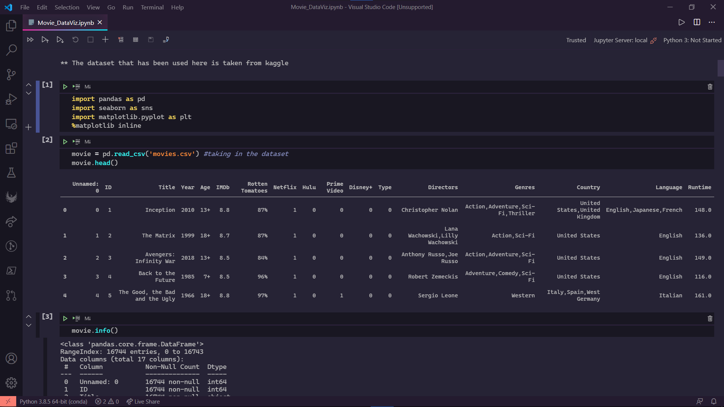

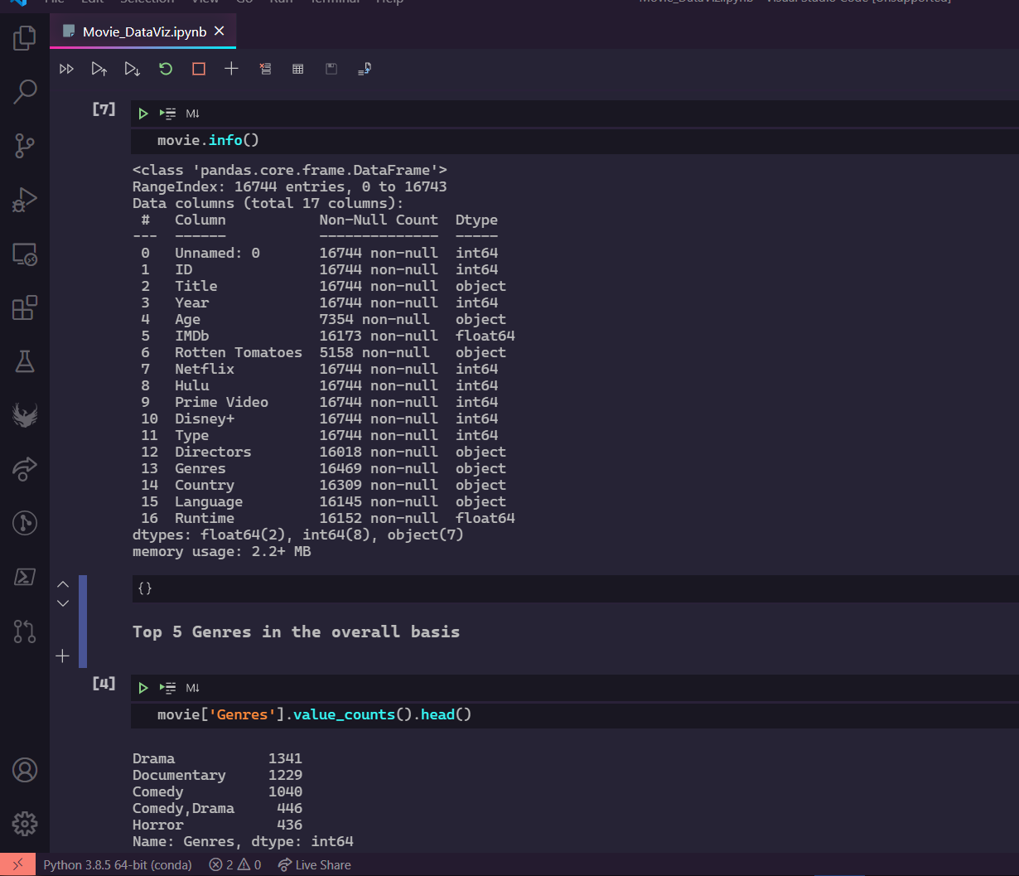

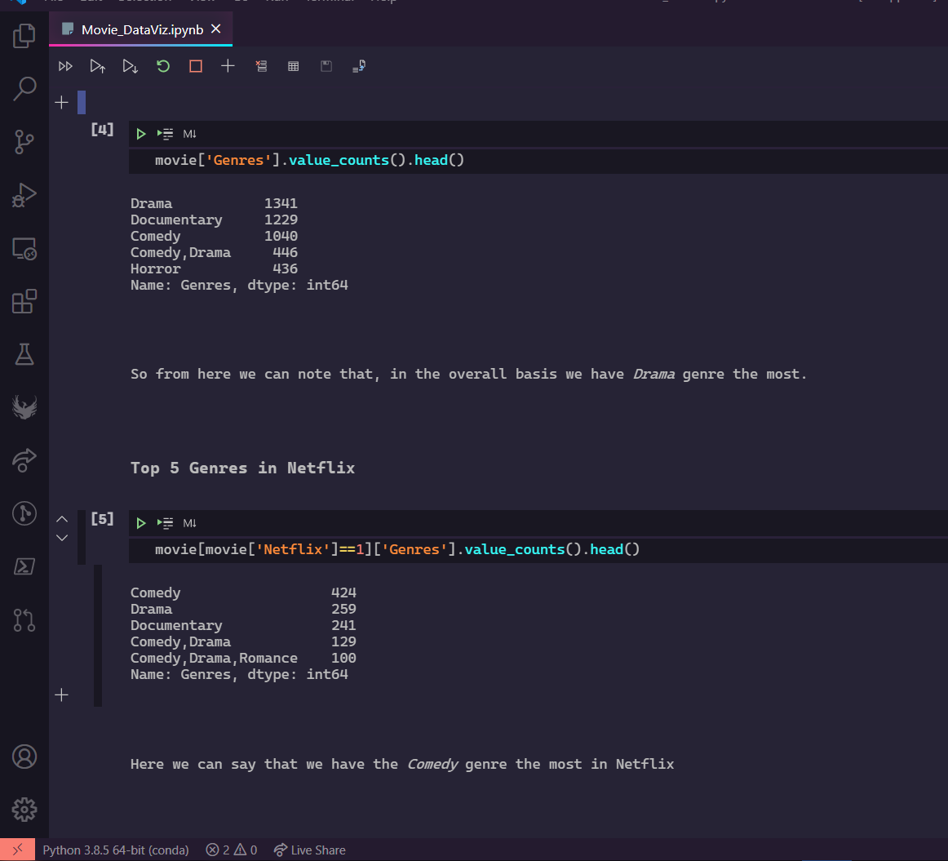

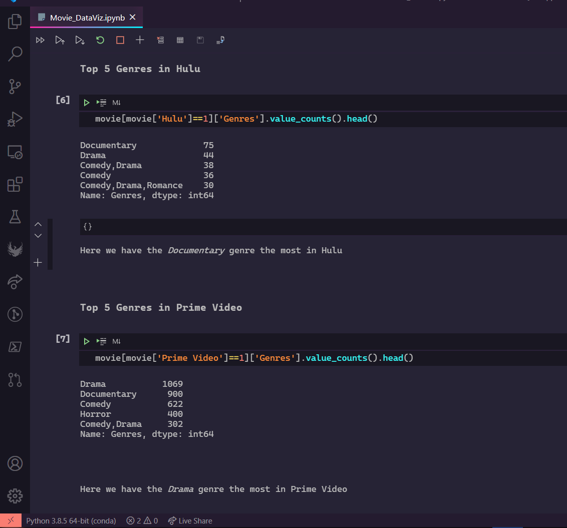

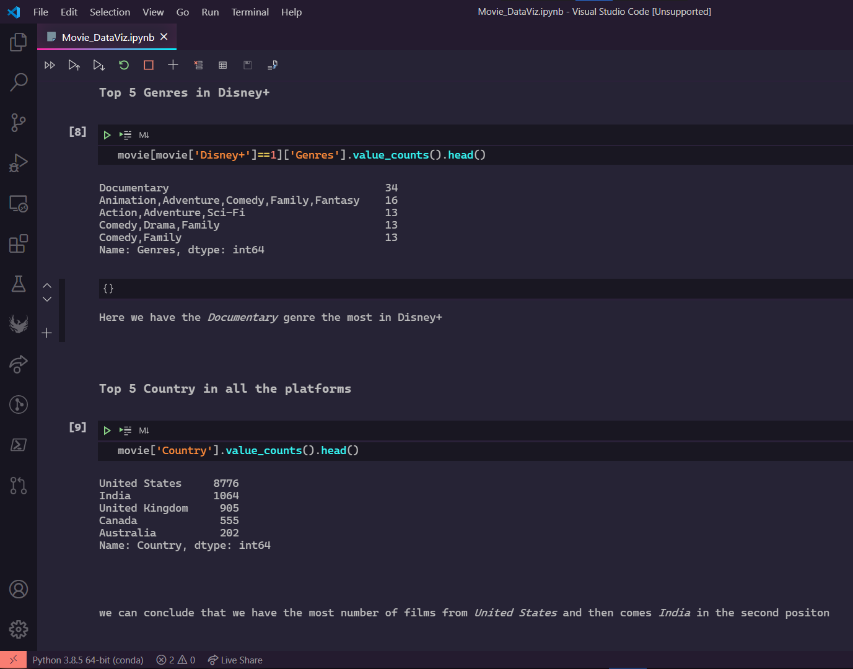

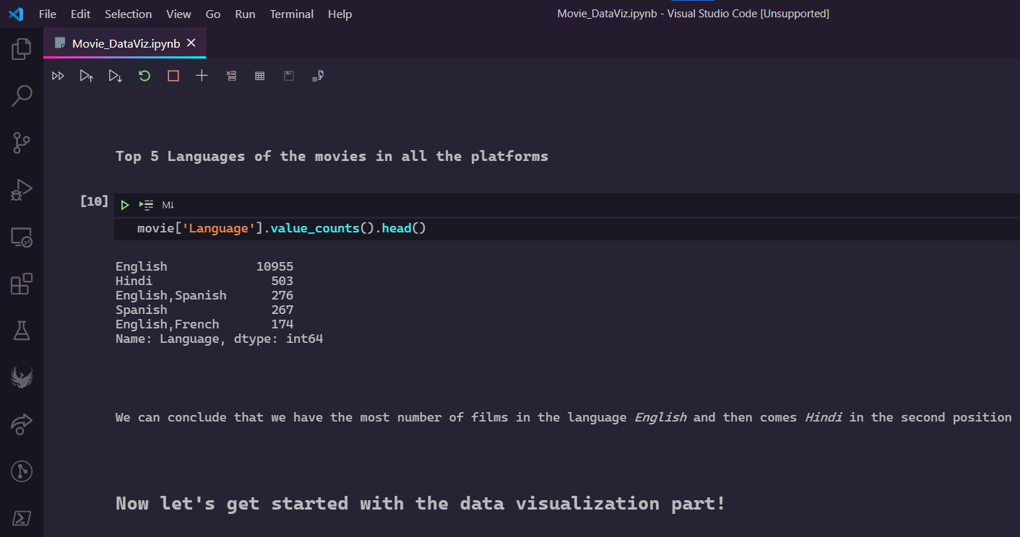

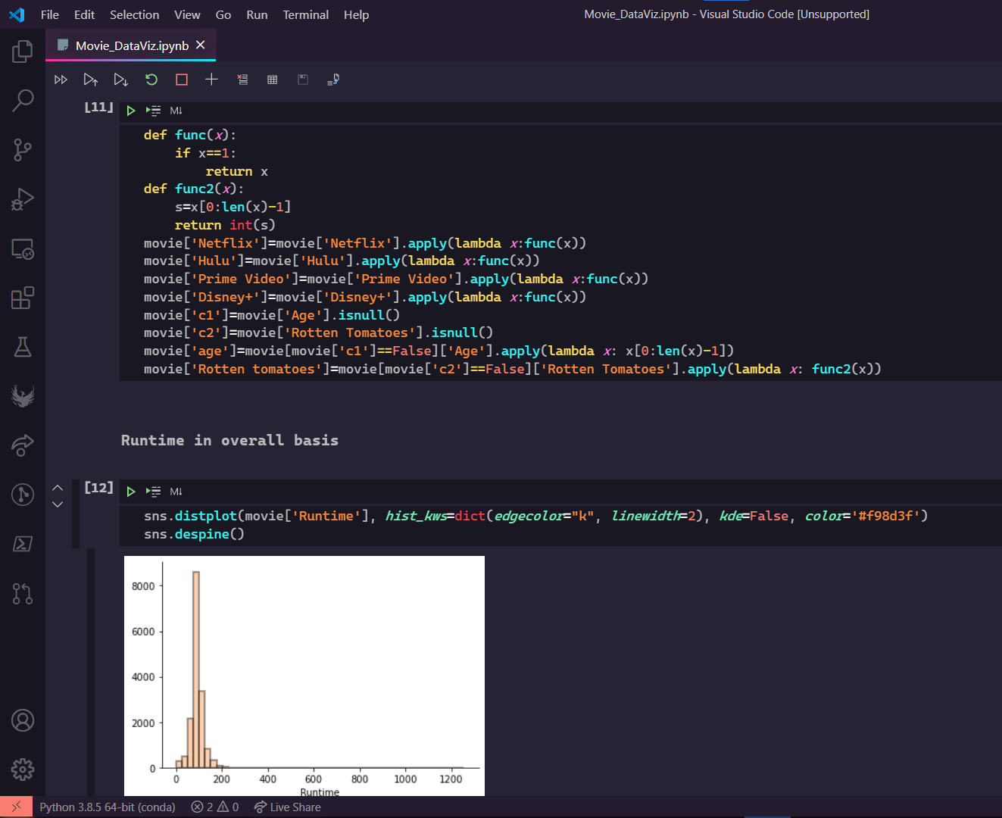

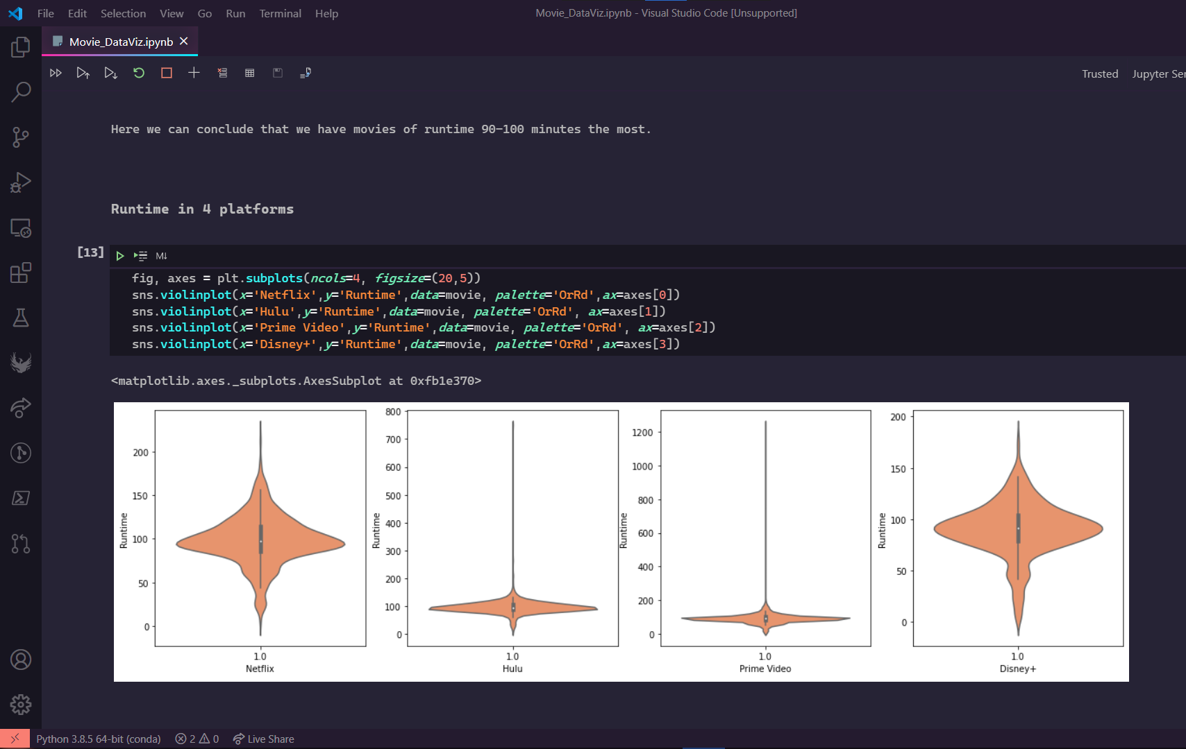

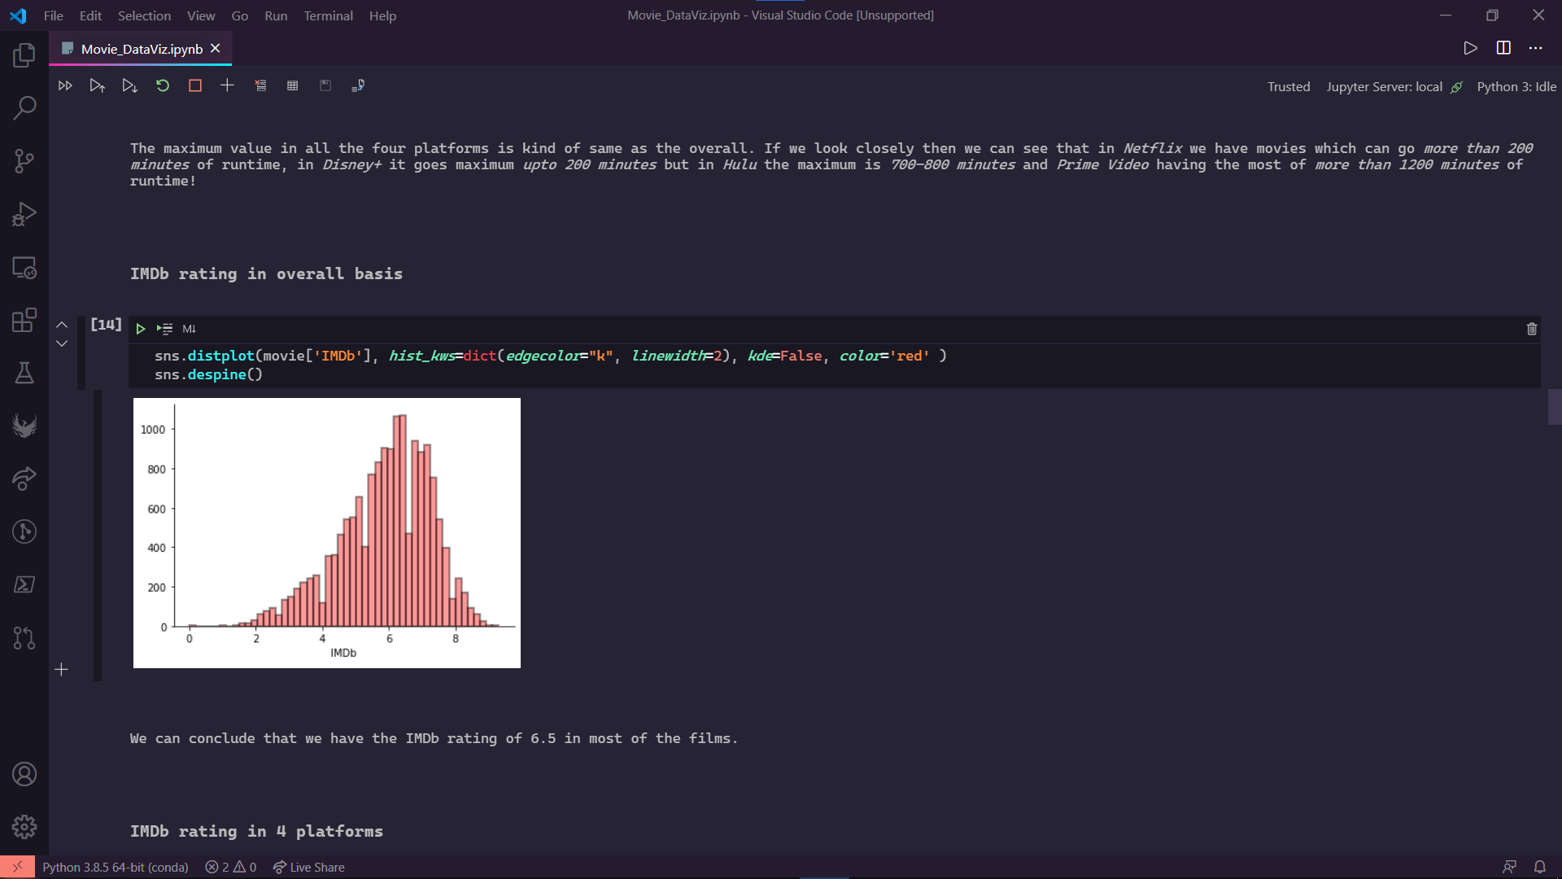

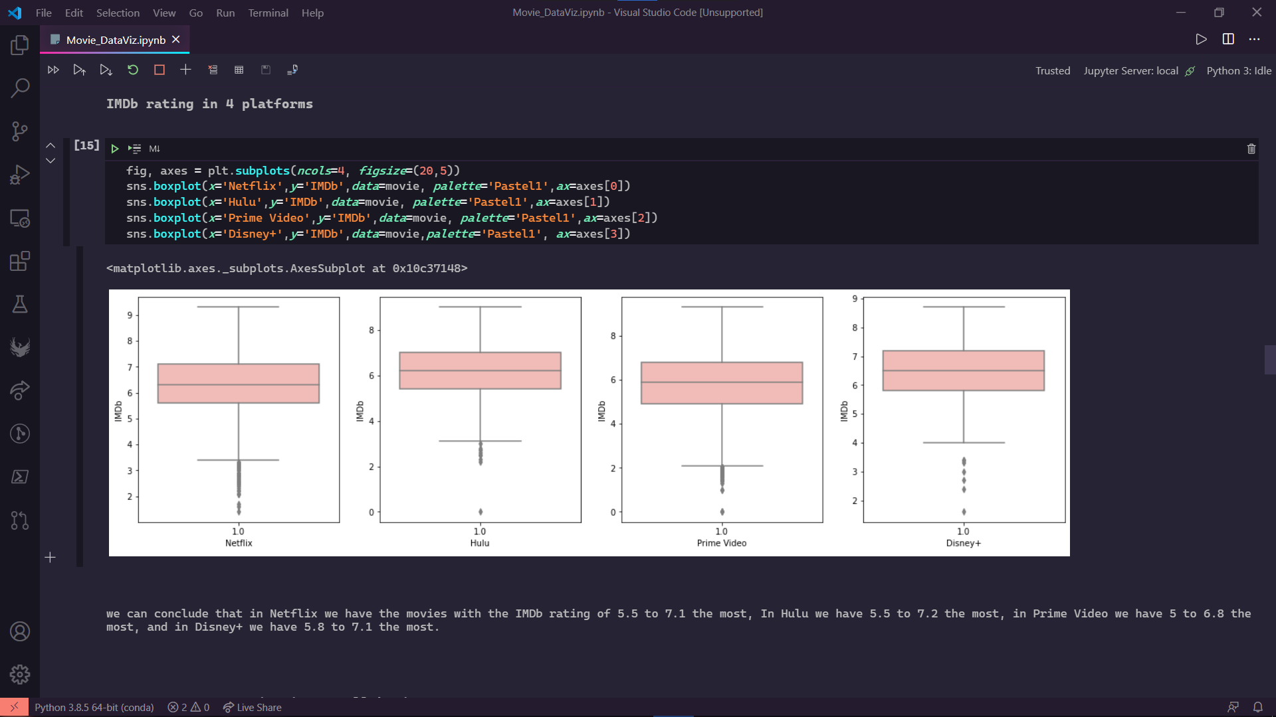

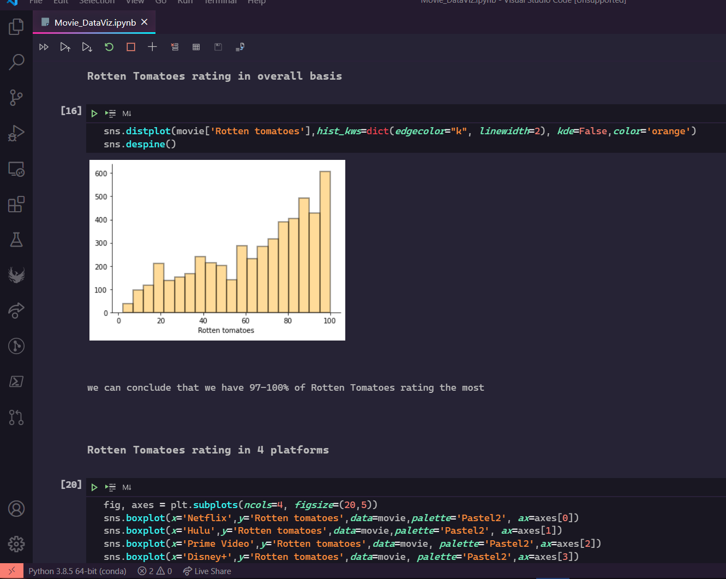

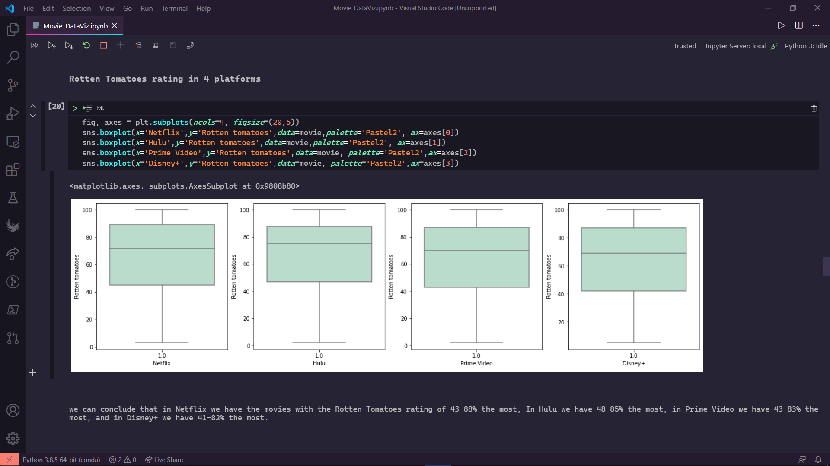

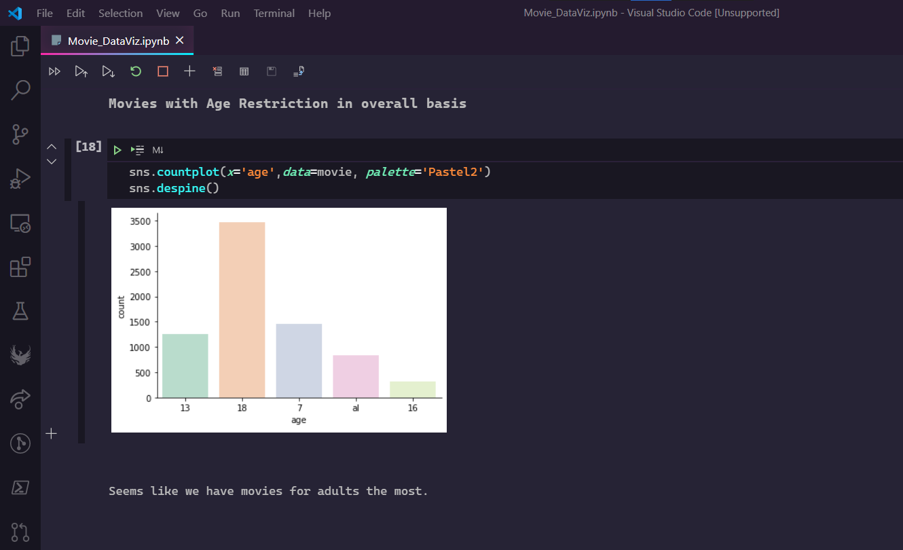

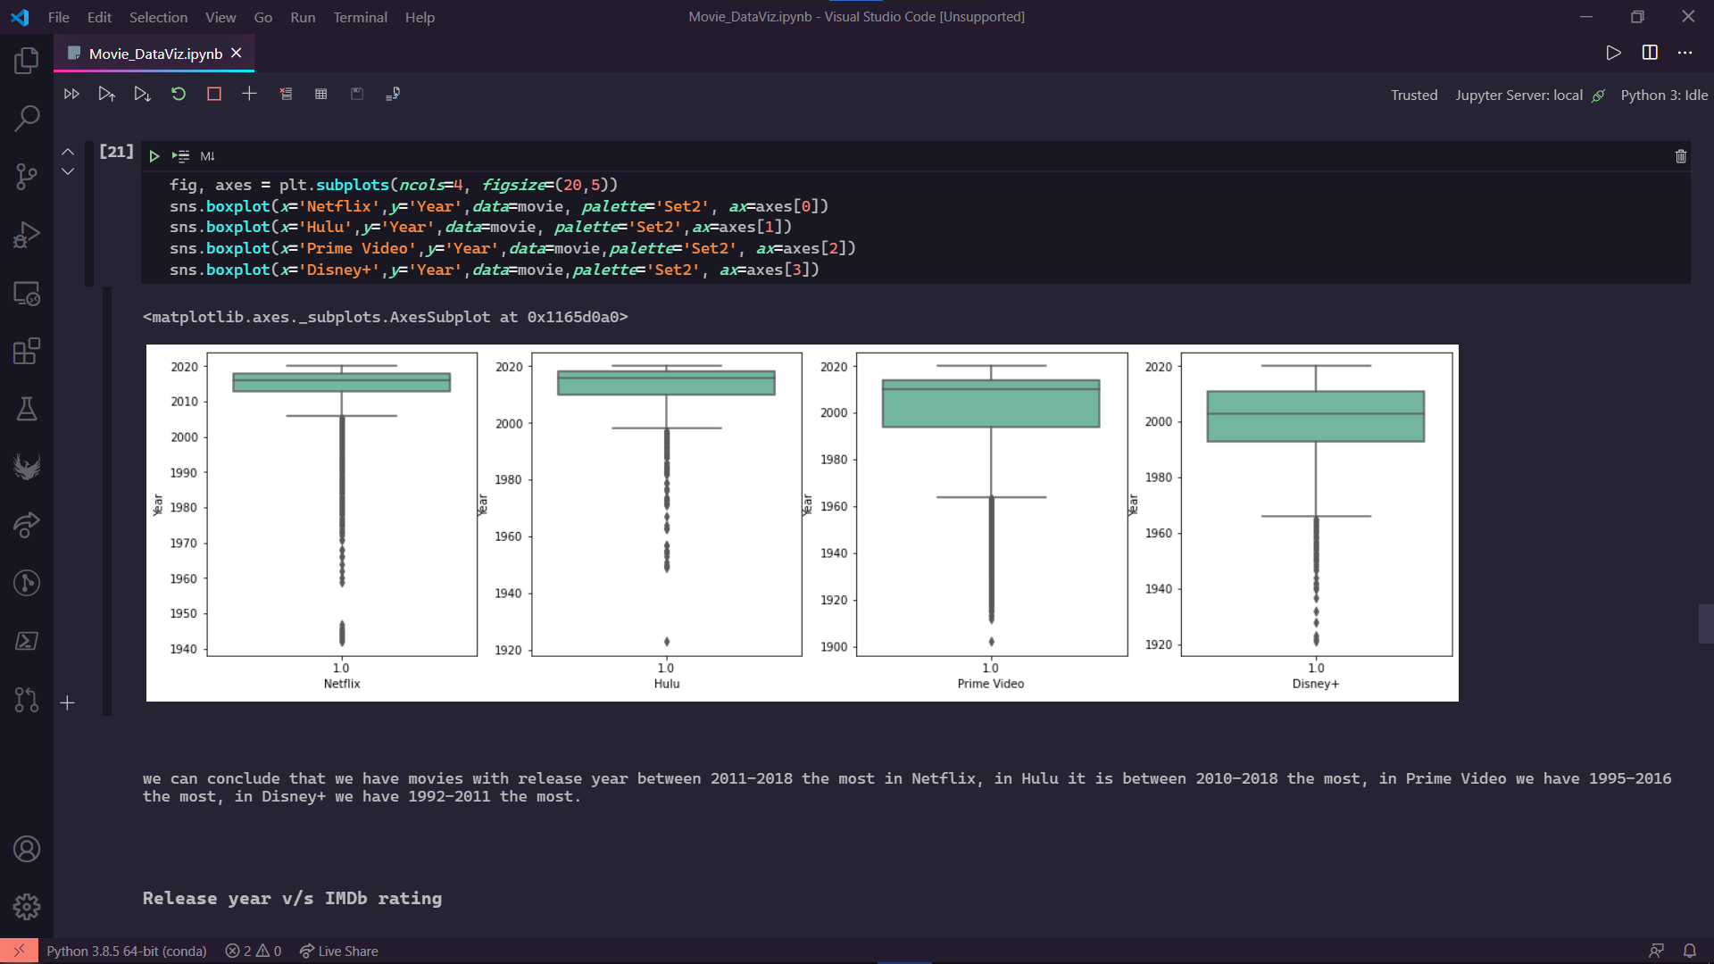

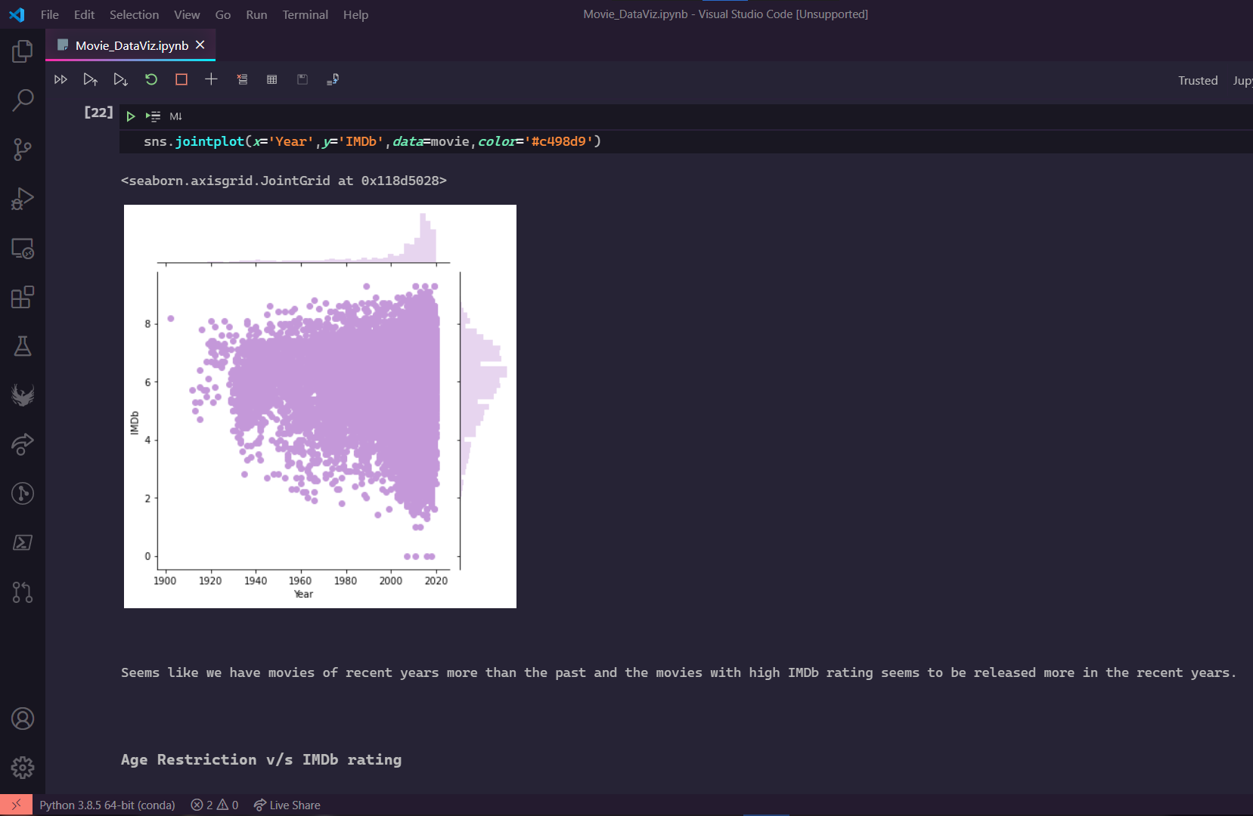

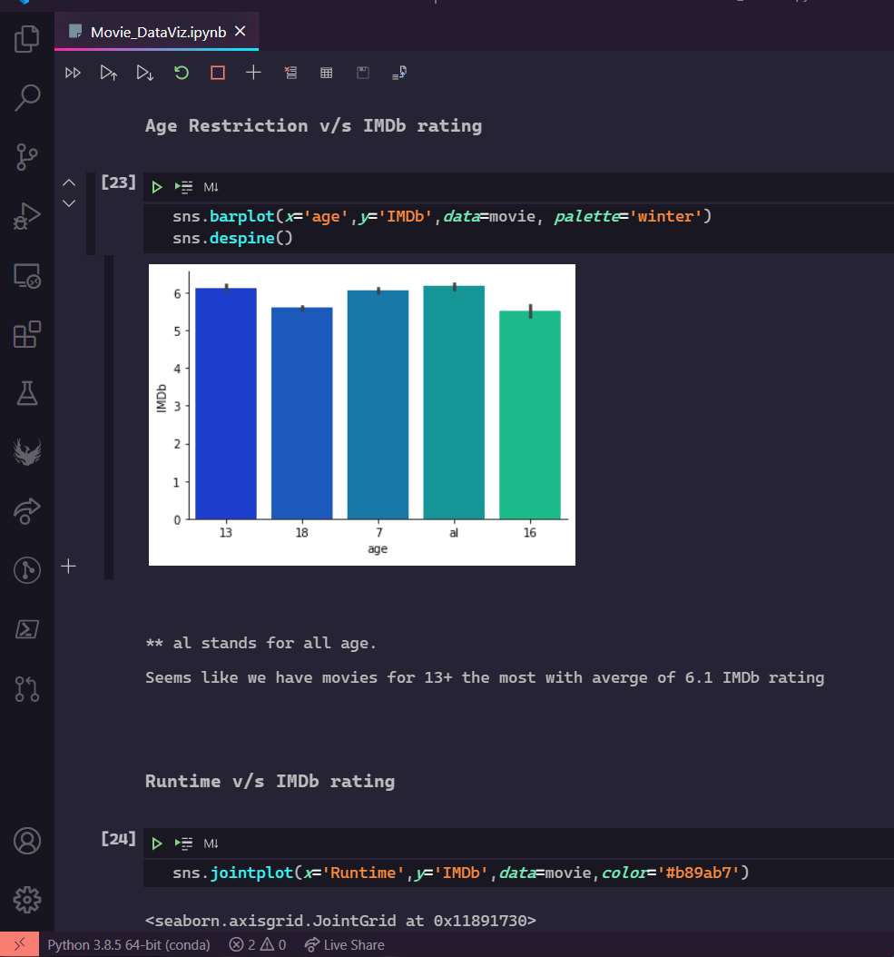

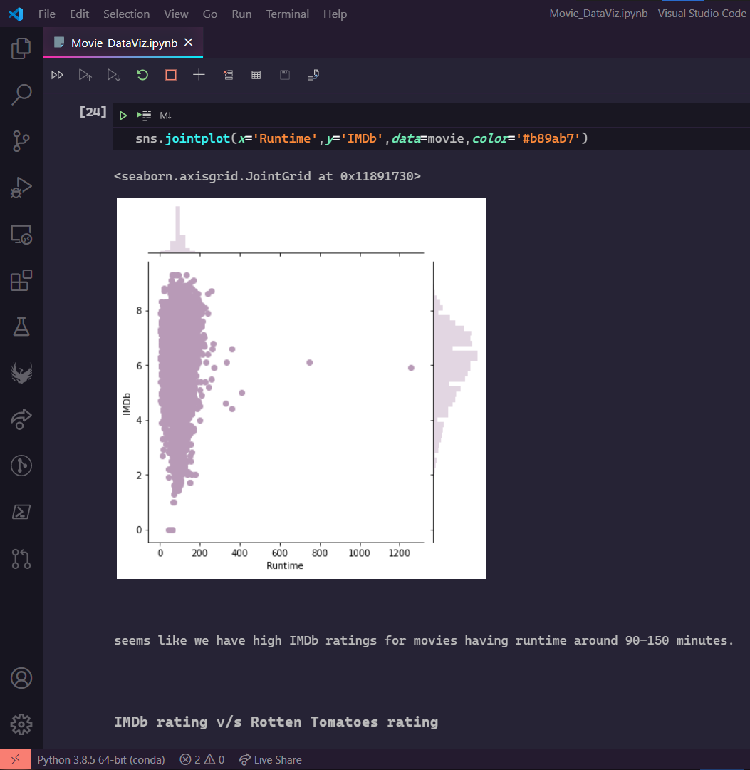

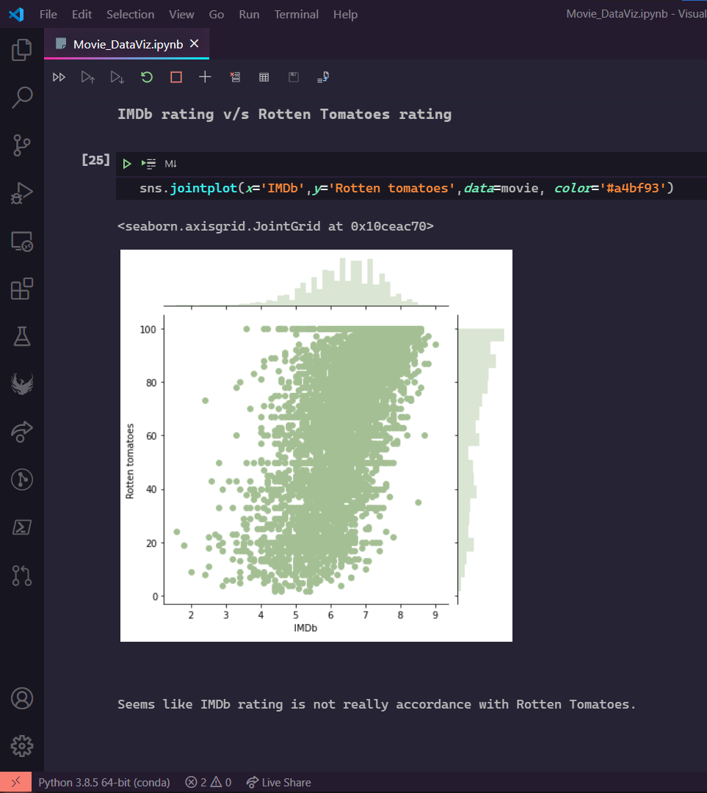

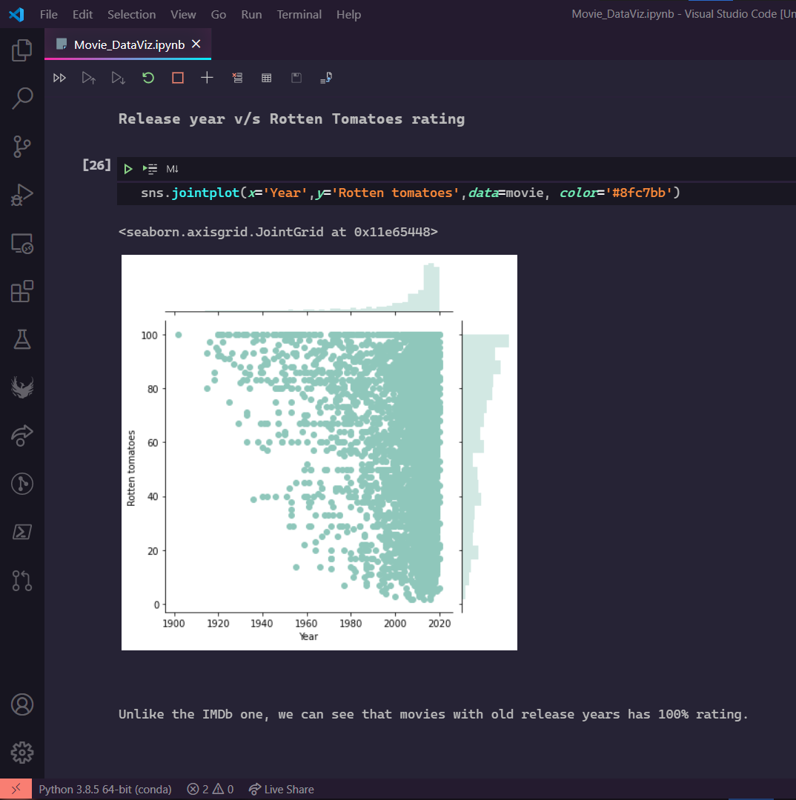

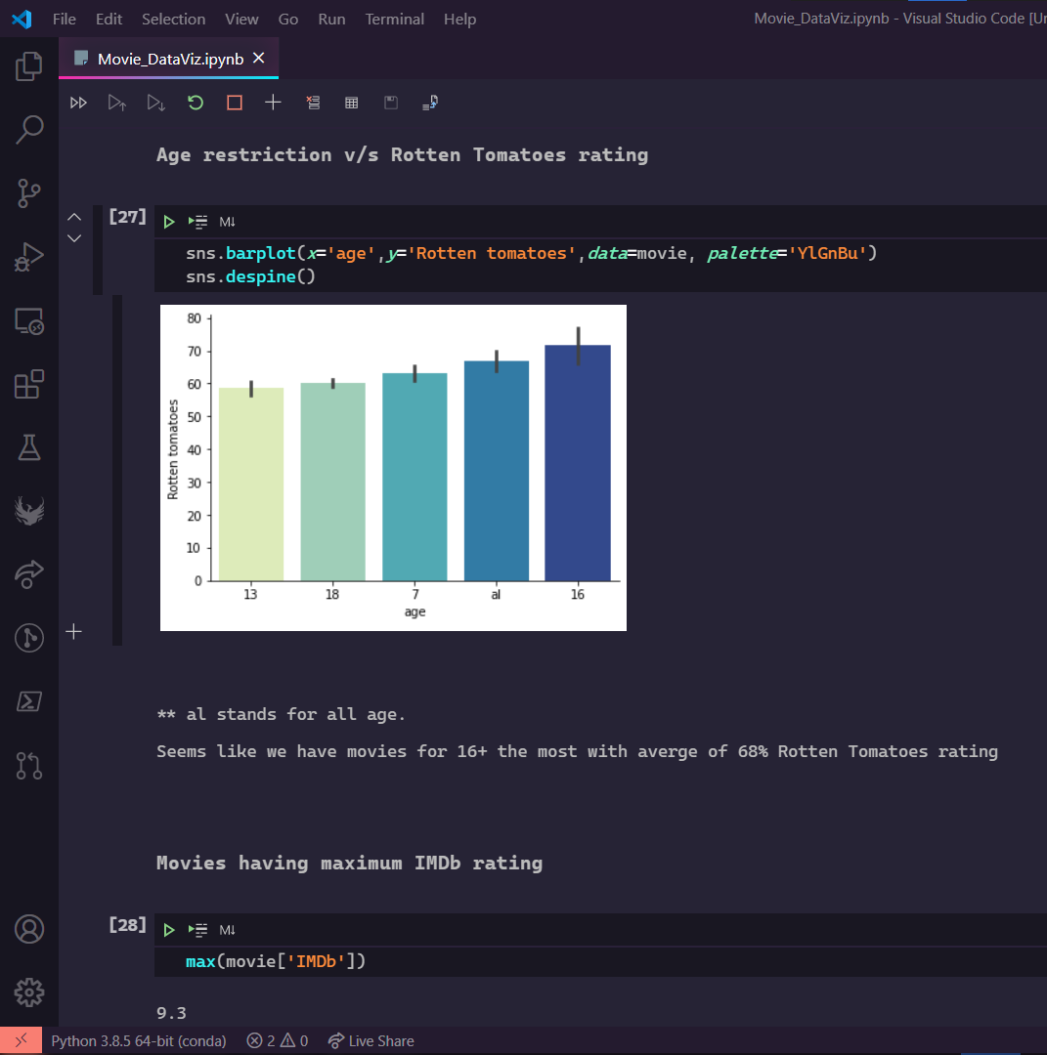

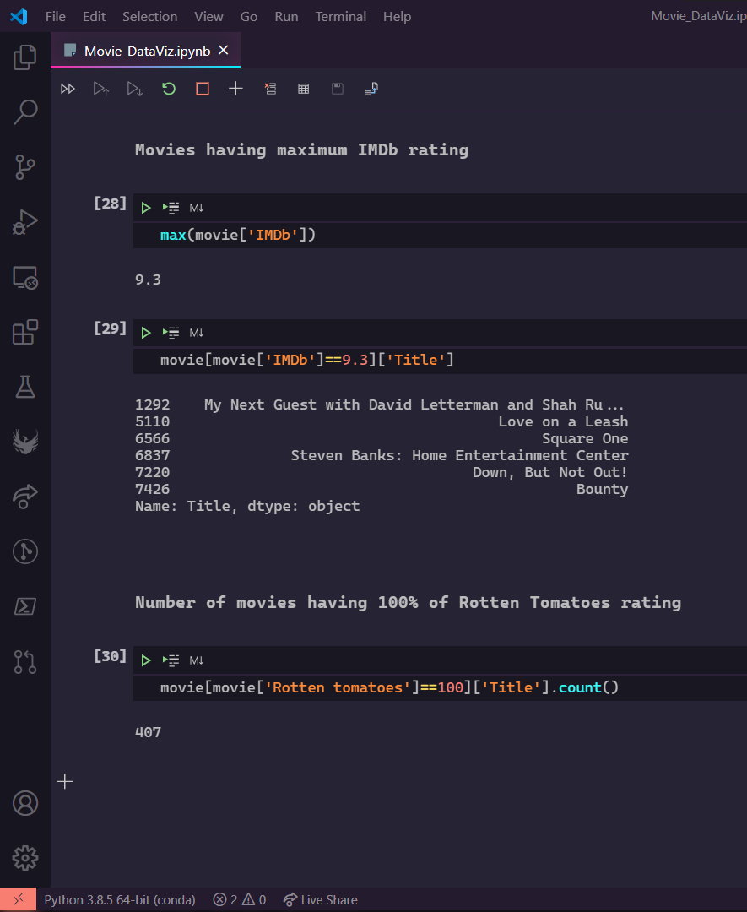

**Conclusion**

The afore shows the analysis of a data set of movies available over popular streaming services Netfilx,Hulu, Disney+ and Prime Video. Acquired from Kaggle under the unilicense licensing terms. It shows the response from critic websites and ratings over the streaming service.

**Bibliography**

The data set is acquired under the open sources licensing terms for Educational Projects over Kaggle. And the Code Editor used is also Free and Open Source to the Public.

Our Code is also available as a github repository on our github profiles.

Resources:

* Kaggle.com